**Rosh Hashanah**

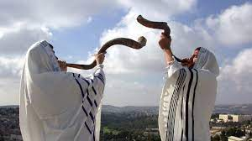The Jewish New Year, is one of Judaism’s holiest days. Meaning “head of the year” or “first of the year,” the festival begins on the first day of Tishrei, the seventh month of the Hebrew calendar, which falls during September or October. Rosh Hashanah commemorates the creation

of the world and marks the beginning of the Days of Awe, a 10-day period of introspection and repentance that culminates in the Yom Kippur holiday, also known as the Day of Atonement. Rosh Hashanah and Yom Kippur are the two “High Holy Days” in the Jewish religion.

**-What Is Rosh Hashanah?**

History and Significance.-Rosh Hashanah is not explicitly mentioned in the Torah, Judaism’s founding religious text, and appears under different names in the Bible. The Torah does, however, mention a sacred occasion that starts on the first day of the seventh month of the Jewish calendar around the time Rosh Hashanah is scheduled. Though the holiday was likely well established by the sixth century B.C., the phrase “Rosh Hashanah” shows up for the first time in the Mishna, a Jewish code of law compiled in 200 A.D.